SIMATS ENGINEERING
ASSESSMENT TOOL 2

COURSE NAME: Database Management Systems COURSE CODE: CSA05

I ADHAVAN CHANDRASEKAR (192521209) certify that this submission is my original work and that I have adhered to the guidelines specified for this assessment. I understand that any violation of academic integrity rules will result in disciplinary action.

Signature of the student:
ADHAVAN CHANDRASEKAR

- A university stores student and course data in a single table. Analyze the structure and identify normalization issues, then redesign it up to 3NF.

ORIGINAL TABLE:

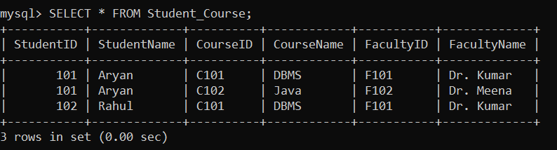

SCENARIO UNDERSTANDING:

A university stores student, course, and faculty details in a single table. This results in repeated data, causing data redundancy and update, insert, and delete anomalies. To improve data consistency and eliminate redundancy, the database must be analyzed and normalized up to Third Normal Form (3NF).

NORMALIZATION ISSUES:

  - Student details are repeated for every course.
  - Faculty information is repeated for students enrolled in the same course.
  - Causes Update Anomaly, Insert Anomaly, and Delete Anomaly.
  - Contains partial and transitive dependencies.

SOLUTION APPROACH:

The database is divided into separate tables such as Student, Department, Course, and Enrollment. This removes redundancy and improves data consistency.

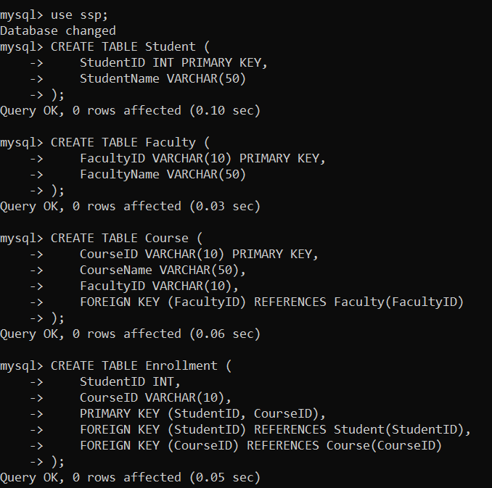

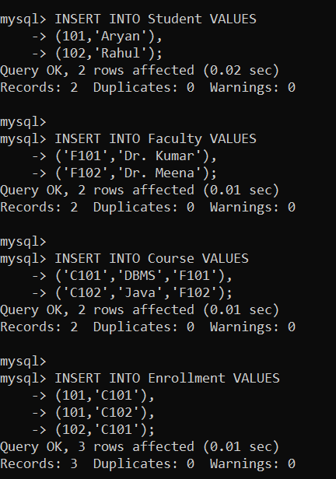

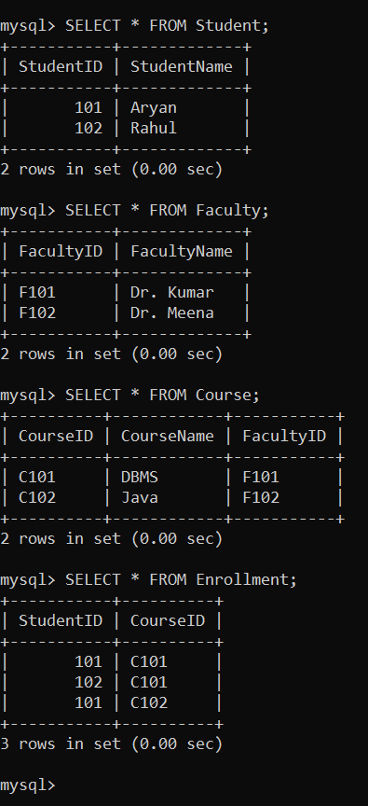

RESULT AND JUSTIFICATION:

The database is successfully normalized up to Third Normal Form (3NF) by separating student, faculty, course, and enrollment information into individual tables. This reduces data redundancy, removes update, insert, and delete anomalies, and improves data integrity and maintainability.

A company database contains employee and department details. Design appropriate SQL queries to retrieve employees working in multiple departments and justify your approach.

SCENARIO UNDERSTANDING:

A company maintains employee and department information in its database. Some employees are assigned to work in more than one department based on project requirements. The database should accurately represent this many-to-many relationship and retrieve employees working across multiple departments efficiently.

SOLUTION APPROACH:

The database is designed using Employee, Department, and Employee_Department tables. A junction table is used to establish the many-to-many relationship between employees and departments. SQL JOIN, GROUP BY, and HAVING clauses are used to retrieve employees working in multiple departments.

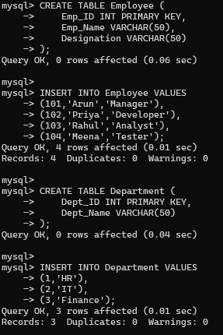

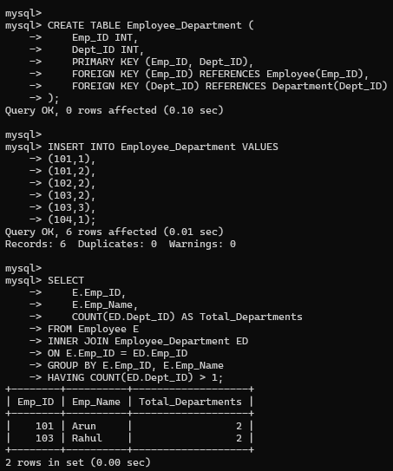

RESULT AND JUSTIFICATION:

The SQL query successfully identifies employees working in multiple departments by combining data from related tables using JOIN and filtering the results with GROUP BY and HAVING. This approach accurately represents the many-to-many relationship, avoids data redundancy, and provides efficient retrieval of employee information for organizational analysis.

- Given a relation with multiple functional dependencies, determine the candidate keys and check whether the relation satisfies BCNF. If not, decompose it.

ORIGINAL TABLE:

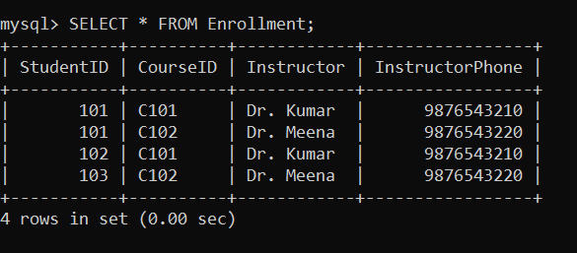

SCENARIO UNDERSTANDING:

The given relation stores student, course, and instructor details in a single table. Since instructor information is repeated for multiple student-course combinations, the relation contains functional dependencies that may lead to redundancy and update anomalies.
Therefore, the relation must be analyzed to determine its candidate keys and checked for Boyce-Codd Normal Form (BCNF).

The relation does not satisfy BCNF because:

  - Instructor → InstructorPhone

Instructor is not a candidate key.
  - Therefore, the relation violates BCNF.

SOLUTION APPROACH:

The functional dependencies are analyzed to identify the candidate key and determine whether the relation satisfies BCNF. Since the dependency Instructor → InstructorPhone violates BCNF, the relation is decomposed into separate Instructor and Enrollment tables. This decomposition removes redundancy while preserving the relationship between students, courses, and instructors.

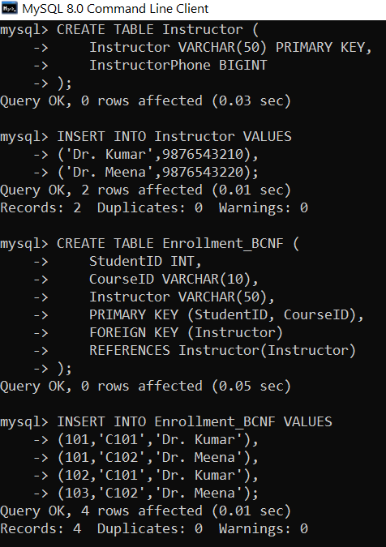

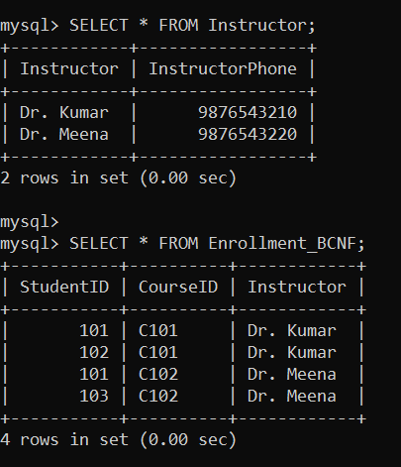

RESULT AND JUSTIFICATION:

The relation was successfully decomposed into BCNF by separating instructor details from enrollment information. The decomposition removes redundancy, eliminates update anomalies, and improves data integrity while preserving all functional dependencies and relationships between the data.

- A banking system requires secure data access. Design views and constraints to ensure data security and integrity for different types of users.

SCENARIO UNDERSTANDING:

A banking system stores customer account information such as account number, customer name, balance, and PIN. Different users require different levels of access to the data. To ensure data security and integrity, Views are used to restrict sensitive information, while Constraints are applied to maintain valid and consistent data.

SOLUTION APPROACH:

A BankAccount table is created with constraints such as PRIMARY KEY, NOT NULL, CHECK, and UNIQUE. A View is created to display only non-sensitive information to general users while hiding confidential details like the PIN.

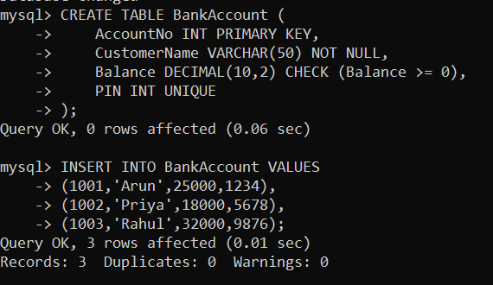

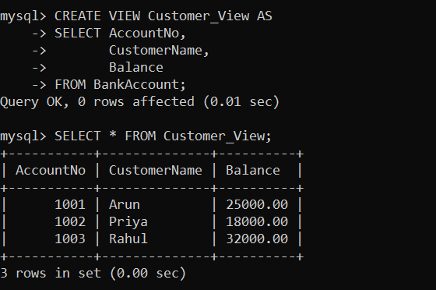

RESULT AND JUSTIFICATION:

The banking database was successfully secured by implementing views and integrity constraints. The Customer_View provides restricted access by displaying only non-sensitive information, while sensitive data such as the PIN remains hidden. The use of PRIMARY KEY, NOT NULL, UNIQUE, and CHECK constraints ensures data accuracy, prevents invalid entries, and maintains database integrity. This design enhances both security and consistency, making the system suitable for different types of users.

- A sales database contains redundant data leading to anomalies. Analyze the schema and apply normalization up to 3NF or BCNF to eliminate redundancy.

SCENARIO UNDERSTANDING:

A sales database stores customer, product, and sales information in a single table. This results in repeated customer and product details, causing data redundancy and anomalies during insertion, updation, and deletion of records. To improve data consistency and eliminate redundancy, the database is normalized up to Third Normal Form (3NF).

SOLUTION APPROACH:

The database is decomposed into separate Customer, Product, and Sales tables. Primary and Foreign Keys are used to establish relationships between the tables, thereby removing redundancy and ensuring data integrity.
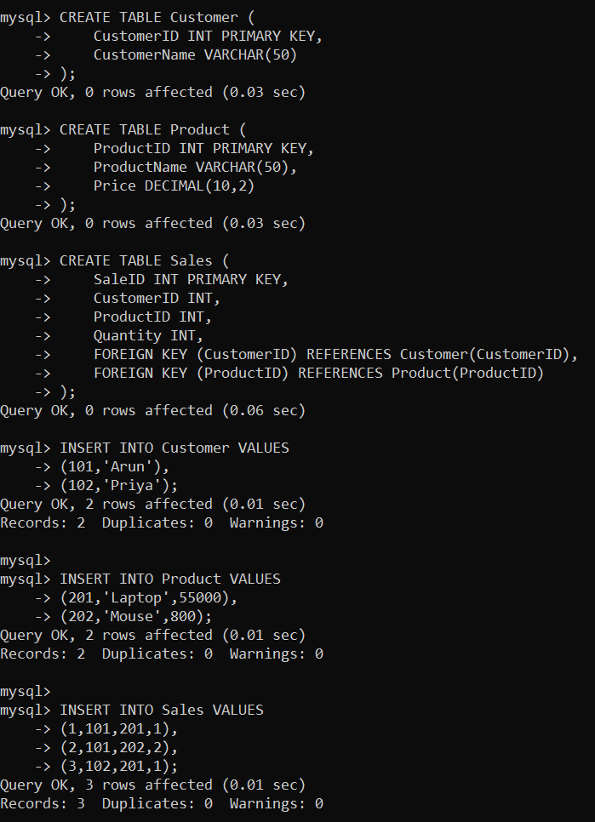

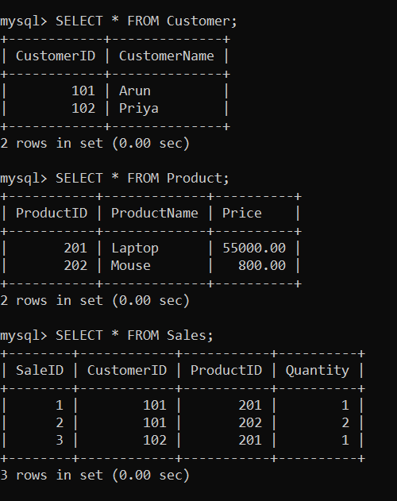

RESULT AND JUSTIFICATION:

The sales database was successfully normalized up to Third Normal Form (3NF) by separating customer, product, and sales information into individual tables. This eliminates data redundancy, removes update, insert, and delete anomalies, and maintains relationships using primary and foreign keys. The normalized design improves data consistency, integrity, and overall database efficiency.

- Given a dataset of customers and orders, write SQL queries using joins and subqueries to retrieve meaningful information such as frequent customers.

SCENARIO UNDERSTANDING:

A company maintains separate tables for Customers and Orders. Each customer can place multiple orders. The objective is to identify frequent customers using JOIN and Subquery operations to retrieve meaningful business information.

SOLUTION APPROACH:

The database is designed using Customer and Orders tables. A JOIN combines customer and order details, while a Subquery identifies customers who have placed more than one order.

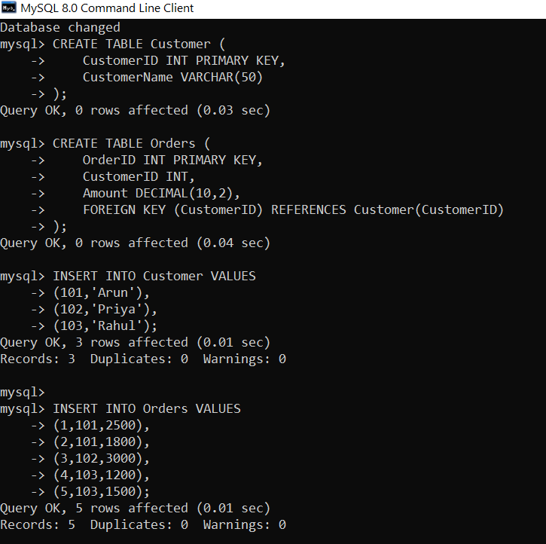

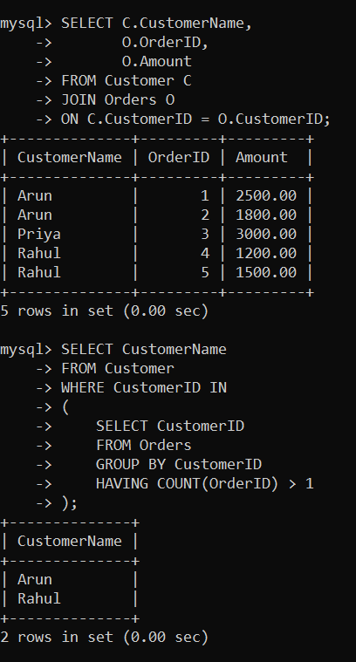

RESULT AND JUSTIFICATION:

The required information was successfully retrieved using JOIN and Subquery operations. The JOIN combines customer and order details, while the subquery identifies customers who have placed multiple orders. This approach efficiently retrieves meaningful business information, reduces query complexity, and improves database analysis.

- A relation contains multi-valued dependencies. Analyze the structure and decompose it into 4NF, explaining the reasoning.

SCENARIO UNDERSTANDING:

A relation contains multi-valued dependencies, where one attribute is associated with multiple independent values. This results in redundant data and unnecessary duplication. To eliminate redundancy and improve data consistency, the relation is decomposed into Fourth Normal Form (4NF).

SOLUTION APPROACH:

The relation is analyzed to identify the multi-valued dependencies. The table is then decomposed into separate relations so that each table contains only one independent multi-valued attribute, thereby satisfying 4NF.

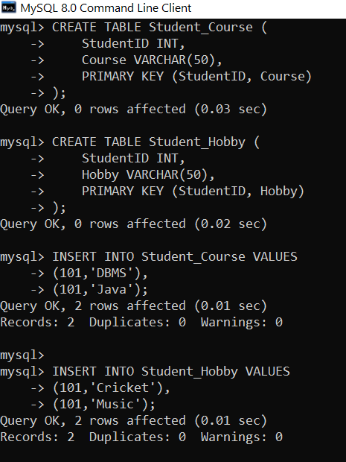

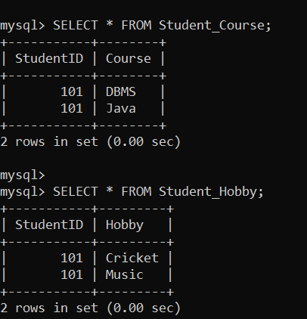

RESULT AND JUSTIFICATION:

The relation was successfully decomposed into Fourth Normal Form (4NF) by separating the independent multi-valued attributes into Student_Course and Student_Hobby tables. This removes redundancy, eliminates multi-valued dependencies, prevents update anomalies, and improves data consistency while preserving all required information.

- A database designer used improper constraints, leading to inconsistent data. Evaluate the schema and suggest appropriate integrity constraints.

SCENARIO UNDERSTANDING:

A database stores customer information without proper integrity constraints. As a result, duplicate records, NULL values, and invalid data can be entered, leading to inconsistencies. To improve data integrity, appropriate constraints must be applied to the table.

SOLUTION APPROACH:

The database schema is evaluated, and integrity constraints such as PRIMARY KEY, NOT NULL, UNIQUE, CHECK, and FOREIGN KEY are applied to ensure accurate and consistent data while preventing invalid entries.

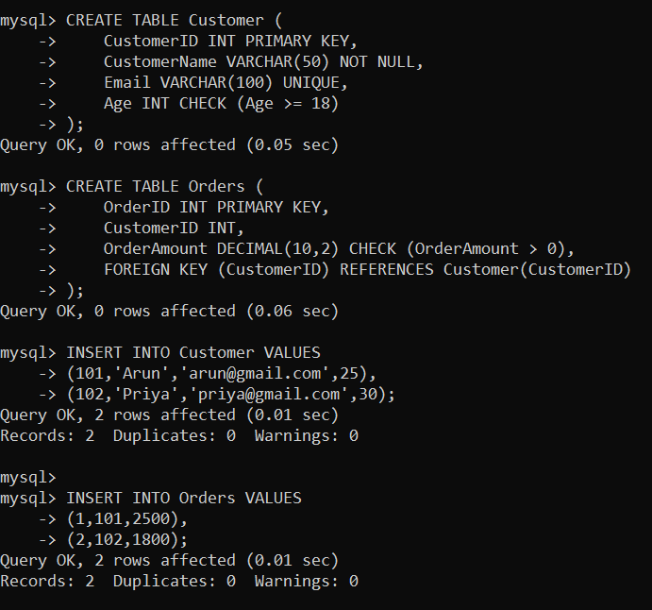

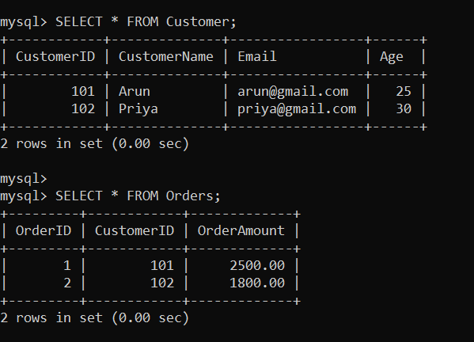

RESULT AND JUSTIFICATION:

The schema was successfully improved by applying PRIMARY KEY, NOT NULL, UNIQUE, CHECK, and FOREIGN KEY constraints. These constraints prevent duplicate records, NULL values, invalid ages and order amounts, and maintain valid relationships between tables. As a result, the database becomes more secure, consistent, and reliable by ensuring data integrity and reducing inconsistencies.

- For a given relational schema, analyze the presence of join dependencies and decompose it into 5NF to remove redundancy.

SCENARIO UNDERSTANDING:

A database stores Supplier, Product, and Project information in a single table. Since suppliers can supply multiple products to multiple projects, the relation contains join dependencies, resulting in redundant data. To eliminate redundancy and maintain consistency, the relation is decomposed into Fifth Normal Form (5NF).

SOLUTION APPROACH:

The relation is analyzed to identify the join dependency and is decomposed into smaller relations. Separate tables are created for Supplier-Product, Supplier-Project, and Product-Project relationships. This decomposition removes redundancy while preserving all original information.
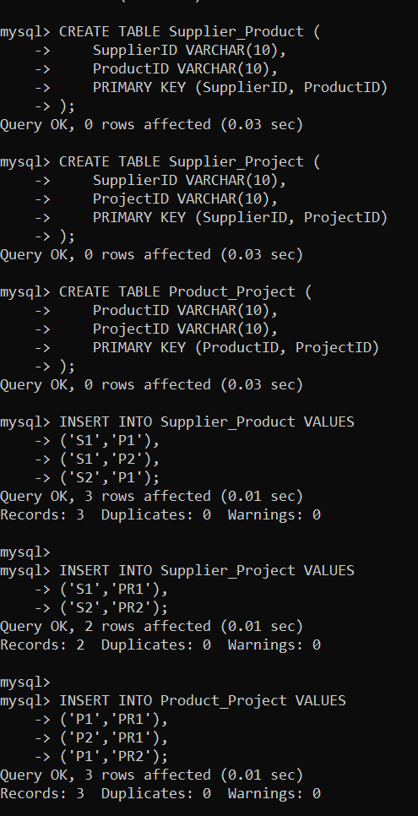

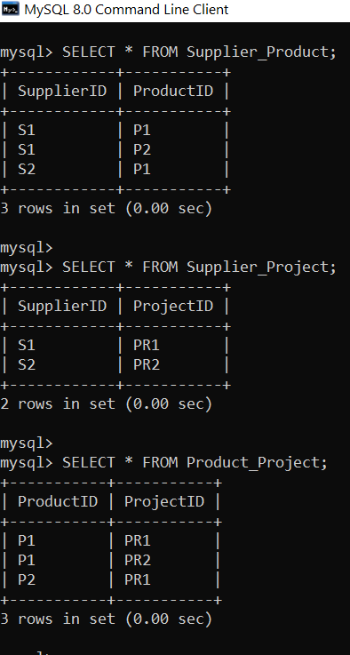

RESULT AND JUSTIFICATION:

The function improves query readability, supports code reuse, and provides consistent results across the database

- A system uses inefficient SQL queries for data retrieval. Analyze the queries and optimize them using joins, indexing concepts, or query restructuring.

SCENARIO UNDERSTANDING:

A database system contains SQL queries that retrieve data inefficiently, resulting in slower execution and increased resource usage. The queries need to be analyzed and optimized using appropriate techniques such as JOINs, Indexing, and Query Restructuring to improve performance.

SOLUTION APPROACH:

The inefficient SQL queries are examined and optimized by replacing unnecessary subqueries with JOINs, creating indexes on frequently searched columns, and restructuring queries to reduce execution time and improve database performance.

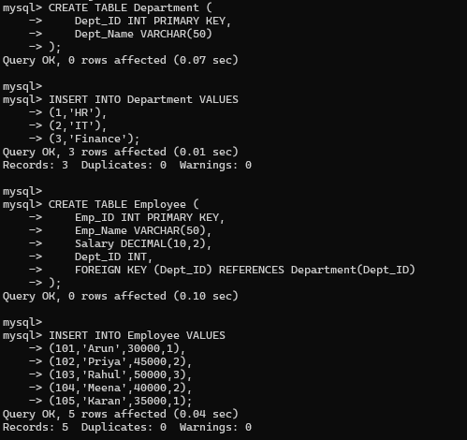

QUERY RESTRUCTURING:
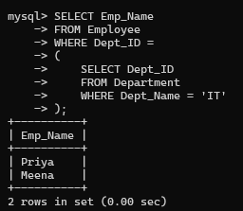

USING JOINS:

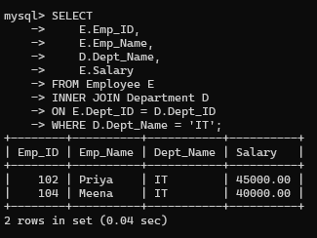

USING INDEX:

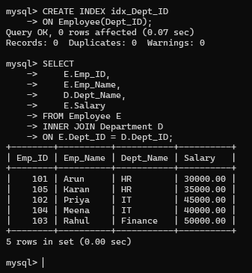

RESULT AND JUSTIFICATION:

The SQL queries were successfully optimized using JOINs, Indexing, and Query Restructuring. These optimizations reduce unnecessary operations, improve query execution speed, minimize resource usage, and enhance overall database performance while producing the same results.

